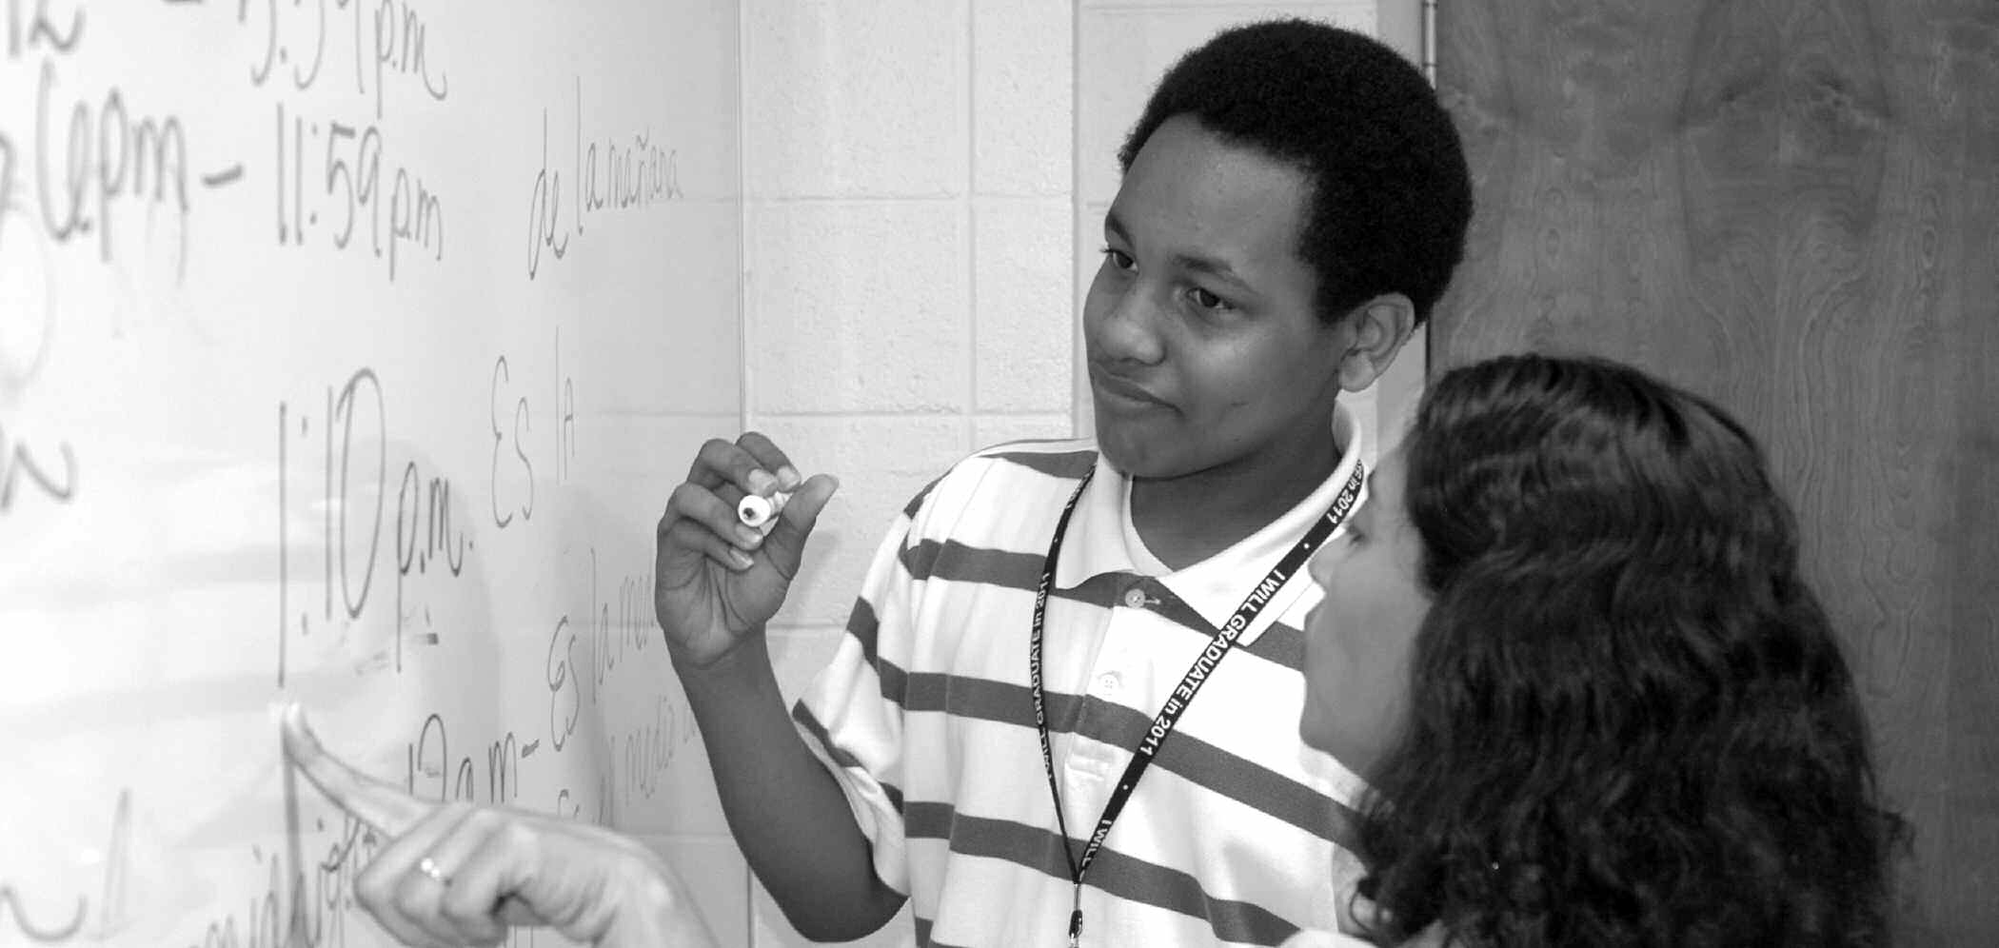

COURSE

DESCRIPTIONS

**Contents**

Accounting ..................................................................169

Albany State University ..............................................170

Art ...............................................................................170

Biology ........................................................................172

Business Administration .............................................176

Business Information Systems and Education ............176

Chemistry ....................................................................178

Computer Science .......................................................180

Cooperative Education ................................................181

Criminal Justice...........................................................182

Learning Support.........................................................183

Driver Education .........................................................185

Early Childhood Development....................................185

Economics ...................................................................186

**Course**

**Descriptions**

Education ....................................................................187

Engineering .................................................................187

English ........................................................................188

Entrepreneurship .........................................................190

Finance ........................................................................191

Fine Arts ......................................................................191

Forensic Science .........................................................191

French..........................................................................193

Geography ...................................................................194

German ........................................................................194

Health Education .........................................................194

History.........................................................................195

Honors .........................................................................197

Interdisciplinary Natural Sciences ..............................198

Journalism ...................................................................198

Management ................................................................199

Management-Healthcare Administration ....................200

Marketing ....................................................................200

Mass Communication .................................................201

Mathematics ................................................................203

Media Education .........................................................205

Middle Grades Education............................................205

Military Science ..........................................................205

Modern Languages......................................................206

Music...........................................................................206

Nursing ........................................................................228

Philosophy...................................................................229

Physical Education ......................................................229

Physics ........................................................................231

Political Science ..........................................................232

Psychology ..................................................................235

Recreation ...................................................................238

Social Science .............................................................239

Social Work .................................................................239

Sociology ....................................................................241

Spanish ........................................................................245

Special Education........................................................247

Speech & Theatre ........................................................248

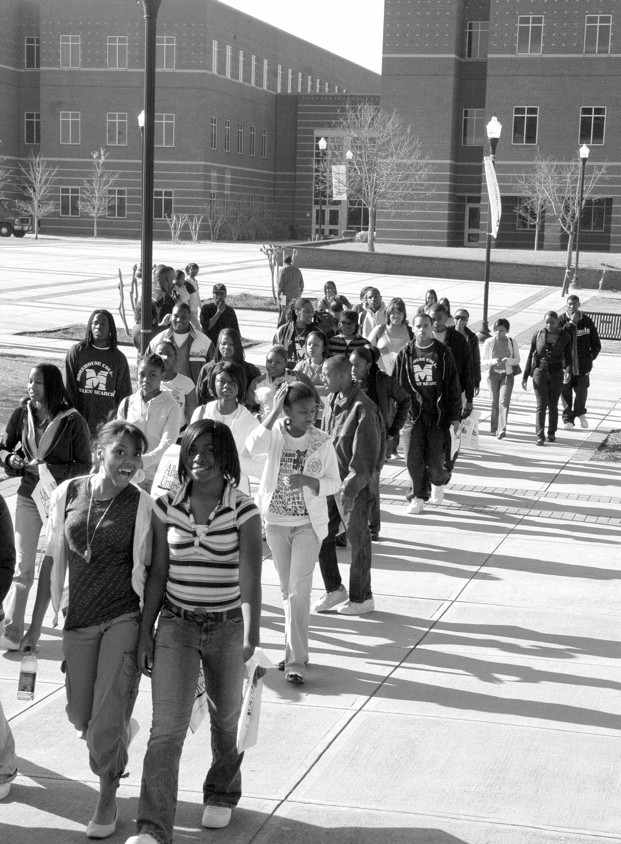

Course Description inside Biology

